Sporty Shoes  
 (An E-commerce platform)

The code for the project is hosted on: [GitHub](https://github.com/redrambo9/Lalit_JAVA_FSD_2_CISCO_Viren)(edit link)  
Developer: **Lalit Kumar**

**Sprint Planning of the Project**

This project is completed in four sprints. The description of individual sprint is as follows:

**Sprint 1:**

* Understanding the customer requirements.

# Sprint 2:

* Designing database tables for Products (shoes) and User.
* Testing of tables.

# Sprint 3:

* Creating different Model, Repository and Controller Class for User and Products.
* Adding required functionalities as methods inside the controller class.
* Using predefined and Custom/Native JPA queries to add functionality.

# Sprint 4:

* Testing of every added functionality using Postman API.

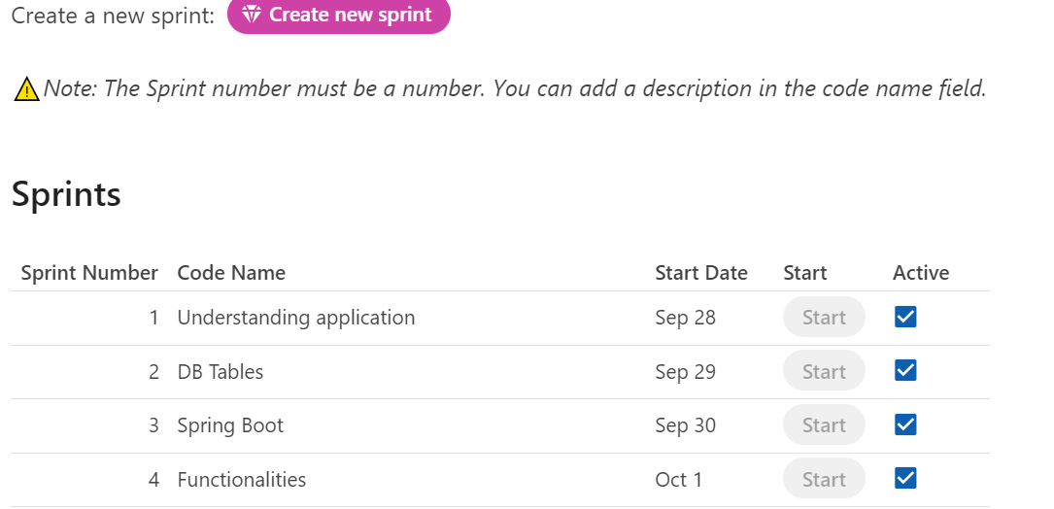

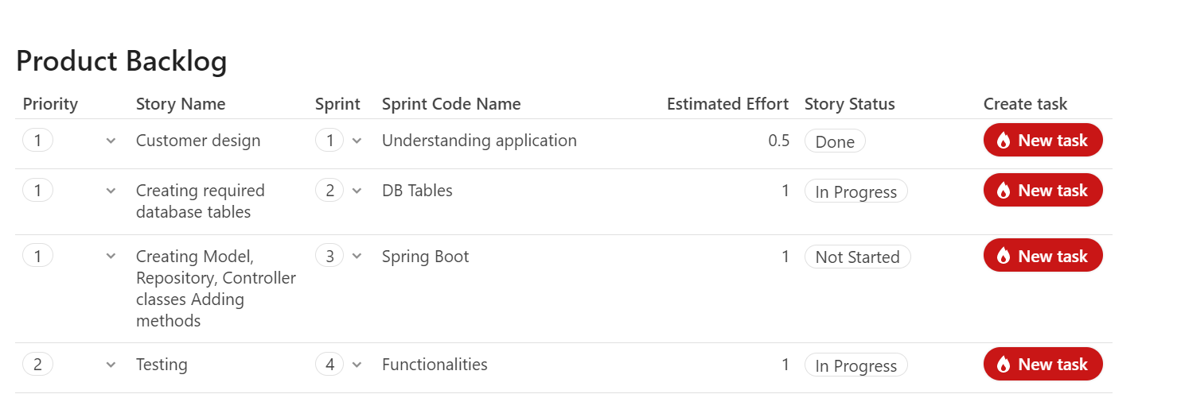

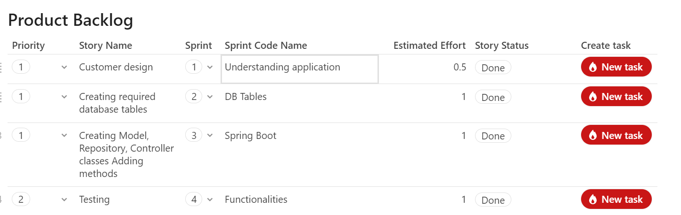

**Technologies Used**

* Spring Boot
* JPA
* JPA Custom & Native Queries
* Postman API Tool
* MySQL
* Basic Java Concepts
* Eclipse

**Tables Schema**

* Product (Product_Id, Product_Name, Season, Brand, Category, Price, Color, Created_Date, Discount)
* User (user_ID, user_name, user_password, user_email, user_phone_number)

**Model Class Variables**

* Product Model Class Variables (productId, productName, season, brand, category, price, color, createdDate, discount)
* User Model Class Variables (userID, username, password, email, phone_number)

**Portal Capabilities**

The application has the following capabilities:

1. Admin
   * Change Password
   * Add Product
   * Delete Product
   * Update Product Details
   * Search any product by using following category filters:
     + Season (Winter/Summer/Rainy)
     + Brand (Nike/Adidas/Puma)
     + Category (Male/Female/Both)
     + Price (High to Low/ Low to High)
     + Color (Black/Brown…. etc)
     + Latest product (Latest product of particular brand)
2. Users
   * Register

**Conclusion:**

Only Backend of the application is designed. The application is seamlessly working without any kind of error. The admin can use any of the defined features.